Inheritance in Java

**Inheritance in java** is a mechanism in which one object acquires all the properties and behaviors of parent object.

The idea behind inheritance in java is that you can create new classes that are built upon existing classes. When you inherit from an existing class, you can reuse methods and fields of parent class, and you can add new methods and fields also.

Inheritance represents the **IS-A relationship**, also known as *parent-child* relationship.

Why use inheritance in java

* For Method Overriding (so runtime polymorphism can be achieved).
* For Code Reusability.

Syntax of Java Inheritance

1. **class** Subclass-name **extends** Superclass-name
2. {
3. //methods and fields
4. }

The **extends keyword** indicates that you are making a new class that derives from an existing class. The meaning of "extends" is to increase the functionality.

In the terminology of Java, a class which is inherited is called parent or super class and the new class is called child or subclass.

Java Inheritance Example

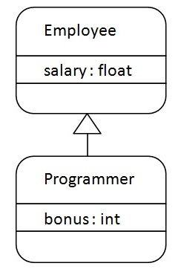

As displayed in the above figure, Programmer is the subclass and Employee is the superclass. Relationship between two classes is **Programmer IS-A Employee**.It means that Programmer is a type of Employee.

1. **class** Employee{
2. **float** salary=40000;
3. }
4. **class** Programmer **extends** Employee{
5. **int** bonus=10000;
6. **public** **static** **void** main(String args[]){
7. Programmer p=**new** Programmer();
8. System.out.println("Programmer salary is:"+p.salary);
9. System.out.println("Bonus of Programmer is:"+p.bonus);
10. }
11. }

Programmer salary is:40000.0

Bonus of programmer is:10000

In the above example, Programmer object can access the field of own class as well as of Employee class i.e. code reusability.

## Types of inheritance in java

On the basis of class, there can be three types of inheritance in java: single, multilevel and hierarchical.

In java programming, multiple and hybrid inheritance is supported through interface only. We will learn about interfaces later.

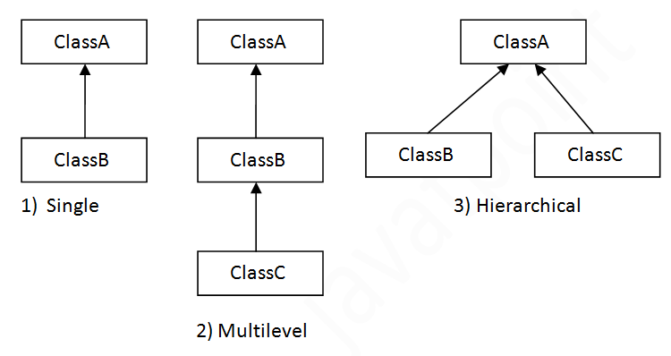

#### Note: Multiple inheritance is not supported in java through class.

When a class extends multiple classes i.e. known as multiple inheritance. For Example:

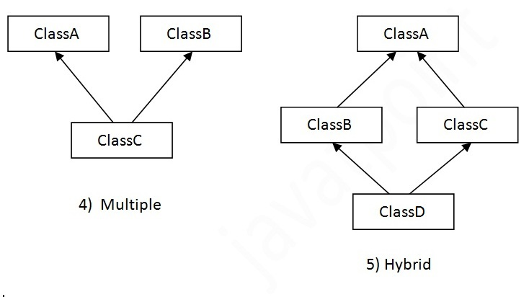

## Single Inheritance Example

*File: TestInheritance.java*

1. **class** Animal{
2. **void** eat(){System.out.println("eating...");}
3. }
4. **class** Dog **extends** Animal{
5. **void** bark(){System.out.println("barking...");}
6. }
7. **class** TestInheritance{
8. **public** **static** **void** main(String args[]){
9. Dog d=**new** Dog();
10. d.bark();
11. d.eat();
12. }}

Output:

barking...

eating...

## Multilevel Inheritance Example

*File: TestInheritance2.java*

1. **class** Animal{
2. **void** eat(){System.out.println("eating...");}
3. }
4. **class** Dog **extends** Animal{
5. **void** bark(){System.out.println("barking...");}
6. }
7. **class** BabyDog **extends** Dog{
8. **void** weep(){System.out.println("weeping...");}
9. }
10. **class** TestInheritance2{
11. **public** **static** **void** main(String args[]){
12. BabyDog d=**new** BabyDog();
13. d.weep();
14. d.bark();
15. d.eat();
16. }}

Output:

weeping...

barking...

eating...

## Hierarchical Inheritance Example

*File: TestInheritance3.java*

1. **class** Animal{
2. **void** eat(){System.out.println("eating...");}
3. }
4. **class** Dog **extends** Animal{
5. **void** bark(){System.out.println("barking...");}
6. }
7. **class** Cat **extends** Animal{
8. **void** meow(){System.out.println("meowing...");}
9. }
10. **class** TestInheritance3{
11. **public** **static** **void** main(String args[]){
12. Cat c=**new** Cat();
13. c.meow();
14. c.eat();
15. //c.bark();//C.T.Error
16. }}

Output:

meowing...

eating...

## Why multiple inheritance is not supported in java?

To reduce the complexity and simplify the language, multiple inheritance is not supported in java.

Consider a scenario where A, B and C are three classes. The C class inherits A and B classes. If A and B classes have same method and you call it from child class object, there will be ambiguity to call method of A or B class.

Since compile time errors are better than runtime errors, java renders compile time error if you inherit 2 classes. So whether you have same method or different, there will be compile time error now.

1. **class** A{
2. **void** msg(){System.out.println("Hello");}
3. }
4. **class** B{
5. **void** msg(){System.out.println("Welcome");}
6. }
7. **class** C **extends** A,B{//suppose if it were
9. Public Static **void** main(String args[]){
10. C obj=**new** C();
11. obj.msg();//Now which msg() method would be invoked?
12. }
13. }

Compile Time Error